婦產部的研究特色與成果

黃富仁醫師總編輯
編輯小組:黃寬慧醫師、林浩醫師、歐家佑醫師、康宏佑博士

1986年高雄長庚醫院婦產科成立，隨著1996年兒童醫院成立，婦產科相關設備隨即遷入到今天兒童醫院。彼時以臨床服務掛帥的醫療，也漸漸地導向兼顧教學和研究，逐步確立為醫學中心的角色。1997年起，婦產科開始次專科化，擴編為婦科（包括婦女泌尿及內視鏡）、產科（優生保健暨高危險妊娠）、婦癌科、及生殖醫學科。醫學研究也朝向精緻專科化。2000年成立生殖醫學實驗室，著重基礎醫學研究，有專任博士統籌。目前在性荷爾蒙、骨質疏鬆、更年期等領域之研究，成果斐然。我們將分成以下六大研究方向介紹

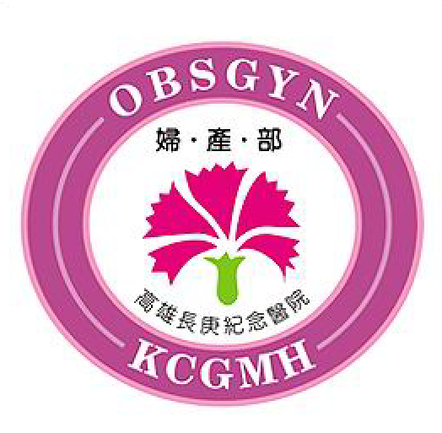

1.人工生殖中心
- 本科中心特色與目標
自從1989.06高雄長庚醫院南部地區首例試管嬰兒誕生起，我們人工生殖團隊在臨床服務與醫學研究方面，均是具有全國性或國際性的指標特色醫療專科。人工協助生殖醫療水準與服務品質，有賴於醫學研究鑽研、創新與開拓發展。因此人工生殖團隊相當積極且努力在於生殖醫學研究。未來期望以高雄長庚既有人工生殖醫療堅實之研究基礎，透過不斷的學習與精煉，提供高高屏地區不孕症病患擁有在地化的國際級醫療服務水準。



- 我們的榮耀：囊胚期胚胎中內層細胞團受維生素A影響，細胞數量減少，細胞凋亡。此研究成果榮登2005.1 生殖醫學論文榮登婦產科SCI頂級雜誌封面
(Fertility and Sterility, 引證係數 3.17)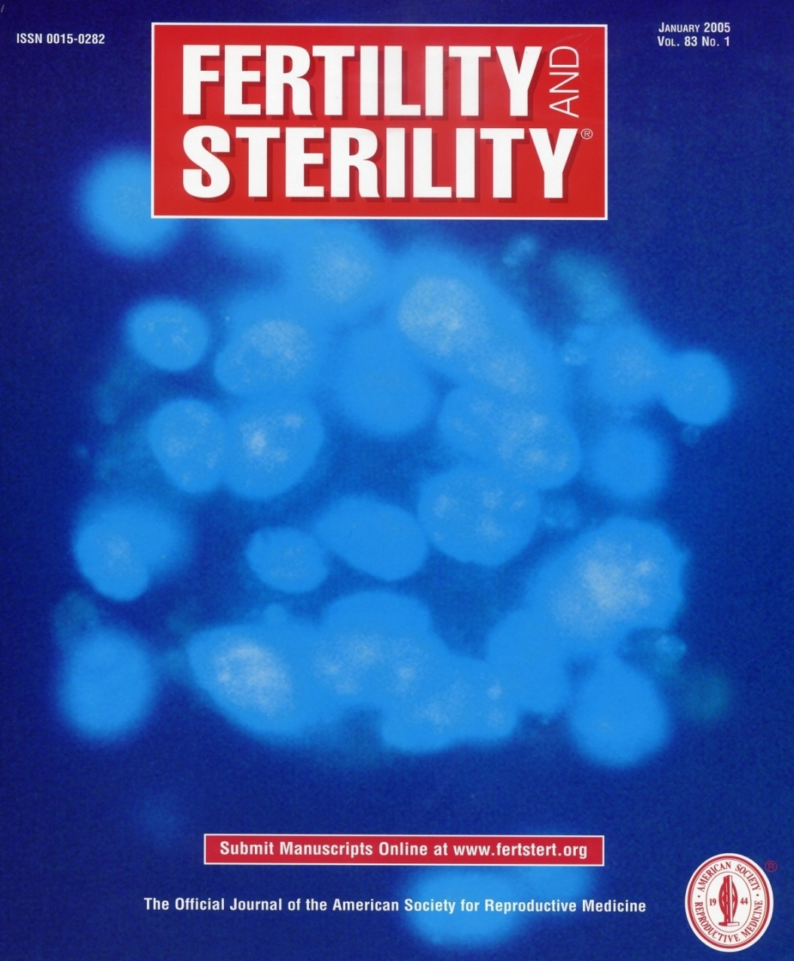

- 我們的榮耀:
1989.06台灣南部地區首例試管嬰兒成功受孕
1996.05亞洲率先發表以無使用PVP做精卵顯微注射技術而懷孕成功
1997.01全國首例以顯微注射技術及冷凍胚胎法懷孕成功
1997.06亞洲首先以冷凍睪丸精子併顯微注射技術懷孕成功
2003.08全國首例無透明帶胚胎植入首例懷孕成功
2005.09全國首例玻璃化冷凍曩胚期胚胎寶寶出生，並於2006.08發表本項技術成果，獲臺灣生殖醫學會最佳論文獎
綜合以上成果榮獲
2007年人工生殖醫療團隊榮獲國家品質標章暨銅獎
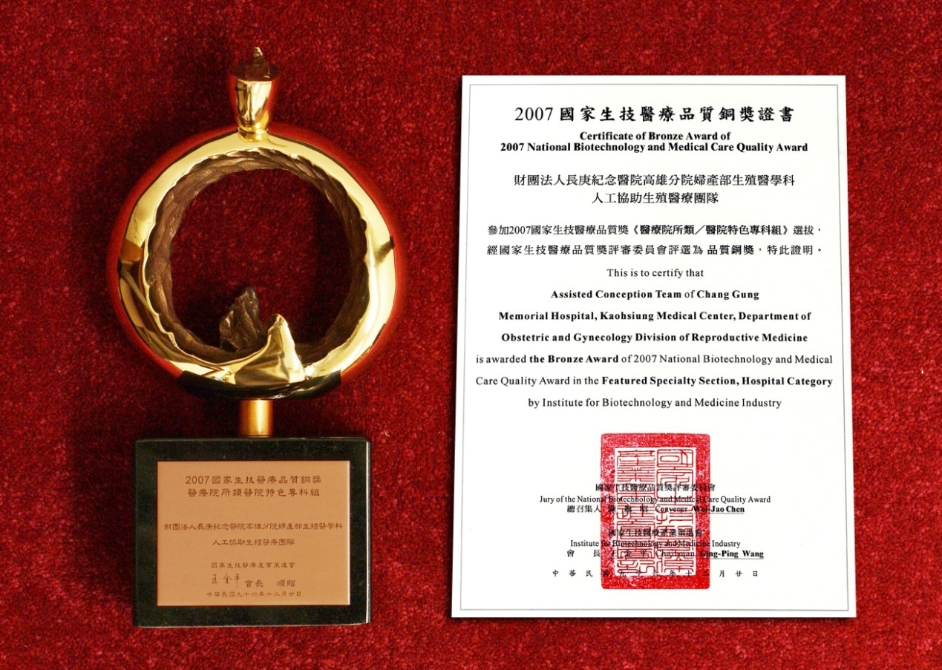

- 研究成員
- 黃國恩教授, 龔福財教授, 黃富仁副教授, 康宏佑副教授
- 蔡孟穎助理教授, 藍國忠助理教授
- 陳彥達醫師, 康智雄醫師, 鄭元佐醫師
- 林秉瑤研究醫師, 王儷蓉研究醫師
- 許玉貞研究助理, 陳玨貞研究助理

- 研究主題
本中心的研究是臨床與基礎緊密結合，二者相輔相成。
- 近十年人工生殖中心的研究計畫共47件
- 雄性素對生殖器官和細胞為主題的一系列研究計畫有14件
- 維生素A衍生物對著床前後時期胚胎的影響為主題的一系列研究計畫有
11件
- 不孕症婦女的刺激排卵機轉為主題的一系列研究計畫有8件
- 更年期為主題的一系列研究計畫有8件
- 冷凍生殖細胞為主題的一系列研究計畫有4件
- 子宮內膜異位致病機轉為主題的一系列研究計畫有2件

- 近十年研究計畫執行概況
年份 | 取得計畫件數/研究經費(元) | 計劃總經費(元)
1998 | CMRP 1件/105,674  NMRP 1件/699,700 | 805,374
1999 | NMRP 3件/1,200,000 | 1,200,000
2000 | NMRP 1件/650,000 | 650,000
2001 | NMRP 3件/1,600,000 | 1,600,000
2002 | CMRP 3件/14,499,750  NMRP 3件/2,833,100  PMRP 1件/2,000,000 | 19,332,850
2003 | NMRP 4件/3,100,000  CMRP 2件/1,357,000  PMRP 1件/747,000 | 5,204,000
2004 | CMRP 2件/9,830,450  NMRP 4件/4,506,600 | 14,337,050
2005 | PMRP 1件/2,592,000  NMRP 7件/5,682,000 | 8,274,000
2006 | MRP 2件/1,650,620  XMRP 1件/370,010  NMRP 5件/4,939,000 | 6,959,630
2007 | CMRP 1件/1,485,450  NMRP 2件/2,350,000 | 3,835,450
2008 | CMRP 1件/734,757  NMRP 1件/1,200,000 | 1,934,575
- 主題研究相關成果

研究成果及應用（包括學術論文發表）

1.研究論文概況

自1996年起至2008年止，國內外醫學雜誌發表的論文共82篇(國外65篇國內15篇)其中經SCI收錄之著作 68 篇。

(1). Impact factor ＞3 的論文有 45篇。

(2).Impact factor ＜1～3 的論文者有7篇。

(3).Impact factor ＜1 的論文有16篇。

1996.05亞洲率先發表以無使用PVP作精卵顯微注射技術而懷孕成功

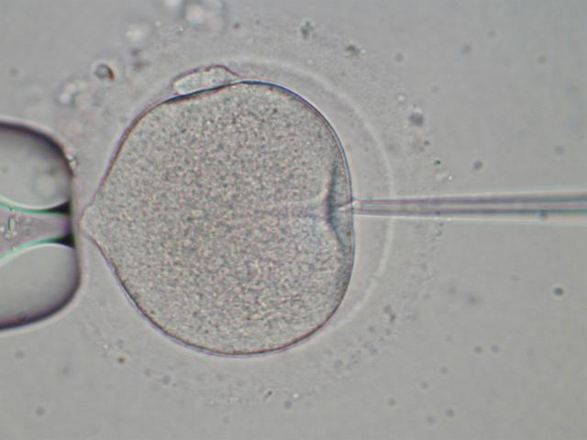

主要代表論文是
Tsai MY, Huang FJ, Kung FT, Lin YC, Chang SY, Wu JF. Influence of polyvinylpyrrolidone on the outcome of intracytoplasmic sperm injection. J Reprod Med 2000; 45(2): 1125-20.

1997.01全國首例以顯微注射技術及冷凍胚胎法懷孕成功
主要代表論文是
Kung FT, Lin YC, Tseng YJ, Huang FJ, Tsai MY, Chang SY. Transfer of frozen-thawed blastocysts that underwent quarter laser-assisted hatching at the day 3 cleaving stage before freezing. Fertil Steril. 2003; 79:893-9.

1997.06亞洲首先以冷凍睪丸精子併顯微注射技術懷孕成功

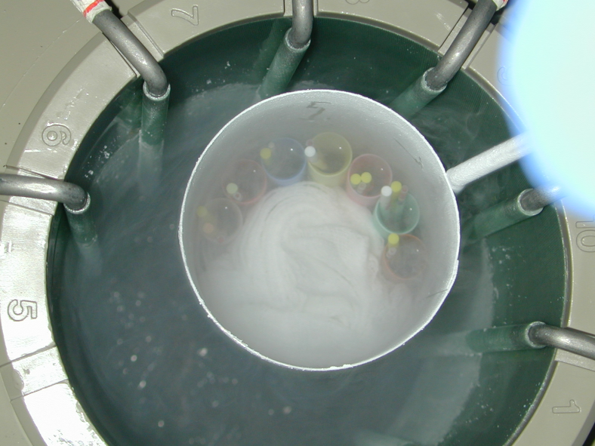
主要代表論文是
- Huang FJ, Chang SY, Tsai MY, Kung FT, Lin YC, Wu JF, Lu YJ. Clinical implications of intracytoplasmic sperm injection using cryopreserved testicular spermatozoa from men with azoospermia. J Reprod Med 2000; 45(4): 310-316.
- Huang FJ, Lan KC, Lin YC, Tsai MY, Kung FT, Chang SY. Impact of duration of cryopreservation of spermatozoa obtained through testicular sperm extraction on intracytoplasmic sperm injection. Fertil Steril 2004; 81(5):1405-7.

2003.08全國首例無透明帶胚胎植入首例懷孕成功
主要代表論文是
Lan KC, Huang FJ, Lin YC, Kung FT, Chang SY. Zona-free versus laser zona-assisted hatching blastocyst transfer: a comparison of outcomes. Fertil Steril. 2008 May 17.

雄性素對生殖器官和細胞為主題的一系列研究計畫
主要代表論文是
- Tsai MY, Yeh SD, Wang RS, Yeh S, Zhang C, Lin HY, Tzeng CR, Chang C. Differential effects of spermatogenesis and fertility in mice lacking androgen receptor in individual testis cells. Proc Natl Acad Sci U S A. 2006; 12;103(50):18975-80.
- Chang CY, Hsuuw YD, Huang FJ, Shyr CR, Chang SY, Huang CK, Kang HY, Huang KE. Androgenic and antiandrogenic effects and expression of androgen receptor in mouse embryonic stem cells. Fertil Steril 2006; 85 Suppl 1:1195-203.
- Lan KC, Hseh CY, Lu SY, Chang SY, Shyr CR, Chen YT, Kang HY, Huang KE. Expression of androgen receptor co-regulators in the testes of men with azoospermia. Fertil Steril. 2008 May;89(5 Suppl):1397-405.

維生素A衍生物對著床前後時期胚胎的影響為主題的一系列研究計畫
主要代表論文是
- Huang FJ, Wu TC, Tsai MY. Effect of retinoic acid on implantation and post-implantation development of mouse embryos in vitro. Hum Reprod 2001; 16(10): 2171-6.
- Huang FJ, Shen CC, Chang SY, Wu TC, Hsuuw YD. Retinoic acid decreases the viability of mouse blastocysts in vitro. Hum Reprod 2003; 18(1): 130-6.
- Huang FJ, Hsu YC, Kang HY, Lan KC, Chang SY, Hsuuw YD, Huang KE. Effects of retinoic acid on the inner cell mass in mouse blastocysts. Fertil Steril, 2005; 83(1): 238-42.
- Huang FJ, Hsuuw YD, Lan KC, Kang HY, Chang SY, Hsu YC,Huang KE. Adverse effects of retinoic acid on embryo development and the selective expression of retinoic acid receptors in mouse blastocysts. Hum Reprod 2006; 21(1):202-9.

不孕症婦女的刺激排卵機轉為主題的一系列研究計畫
主要代表論文是
- Lan KC, Lin YC, Huang FJ, Kung FT, Hsieh CH, Chang SY. Comparison of metaphase II oocytes after stimulation with recombinant follicle-stimulating hormone and urinary follicle-stimulating hormone in a pituitary down-regulation regimen. Fertil Steril 2002; 78(3): 639-41.
- Tsai MY, Lan KC, Huang KE, Huang FJ, Kung FT, Chang SY. Significance of mRNA levels of connexin37, connexin43, and connexin45 in luteinized granulosa cells of controlled hyperstimulated follicles. Fertil Steril 2003; 80: 1437-43.
- Huang FJ, Lan KC, Kung FT, Tsai MY, Chang CY, Huang HW, Lin YC, Chang SY. Human Cumulus-free oocyte maturational profile and in vitro developmental potential after stimulation with recombinant versus urinary FSH. Hum Reprod 2004; 19: 306-15.
- Chang SY, Kang HY, Lan KC, Chang CY, Huang FJ, Tsai MY, Huang KE. Expression of steroid receptors, their cofactors, and aromatase in human luteinized granulosa cells after controlled ovarian hyperstimulation. Fertil Steril. 2005; 83 Suppl 1:1241-7.

子宮內膜異位致病機轉為主題的一系列研究計畫
主要代表論文是
Chang SY, Ho YS : Immunohistochemical analysis of insulin-like growth factor I, insulin-like factor I receptor and insulin-like growth factor II in endometriotic tissue and endometrium. Acta Obstet Gynecol Scand 1997;76: 112-7.

- 人才培育與未來展望
1. 申請國科會與長庚多年期研究計劃。
2. 爭取國家衛生研究院整合型研究計劃。
3. 結合現有的生殖醫學研究實驗室，繼續推出一系列基礎和臨床結合研究計劃，以增加臨床及基礎醫學研究之質與量。
4. 未來的研究計劃主題：
- Correlation between single gene polymorphism of FSH receptor, and outcome of ovarian hyper-stimulation.
- Correlation between single gene polymorphism of estrogen receptor and outcome of ovarian hyperstimulation
- Long-term outcome of newborn from the couples receiving non-PVP intracytoplasmic sperm injection program
- Long-term outcome of newborn from the couples receiving cryoTESE program
- Long-term outcome of newborn from the couples receiving vitrified embryo transfer
- Solid surface vitrification in mice and human ovarian tissues and oocyte
- Androgen receptor downregulate the suppressive effect of Sox9 to normal spermatogenesis
- Expression of androgen receptor coregulators in the testis
- Genetic study of male infertility
- Identification genetic deletion or amplication of genomic regions between obstructive azoopermia and non-obstructive azoospermia with sertoli-cell only syndrome using Array Comparative genomic hybridization
- Role of Sox9 and androgen receptor in the differentiation of mice/human embryonic stem cells
- Role of AMH in the differentiation of mice/human embryonic stem cells

2.婦女微創中心
一 、 本科中心特色與目標
包括腹腔鏡、子宮腔鏡、膀胱鏡等。腹腔鏡手術已可取代近八成傳統婦科
手術，傷口小且美觀、術後疼痛少、恢復也較快。我們提供的腹腔鏡手術
包括子宮摘除、子宮肌瘤摘除、卵巢腫瘤、輸卵管疾病、子宮內膜異位症、
骨盆腔沾黏、子宮外孕、尿失禁及骨盆重建手術等，還有子宮腔鏡經子宮
頸行腫瘤切除手術。另外，在門診也備有軟式子宮腔鏡及膀胱鏡，不需上
麻醉即可檢查。
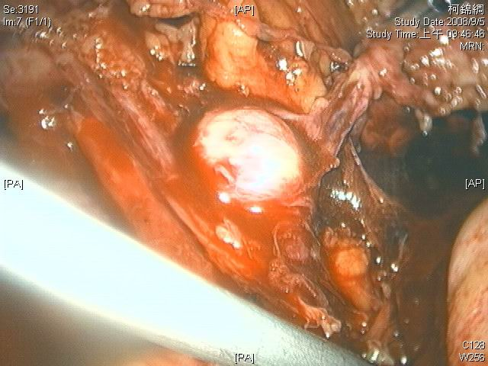
- 我們的榮耀：運用腹腔鏡微創技術作子宮頸外孕的保守治療。此研究論文榮登榮登婦產科SCI頂級雜誌封面 (Fertil Steril. 2004 Jun;81(6):1642-9.引證係數 3.17)
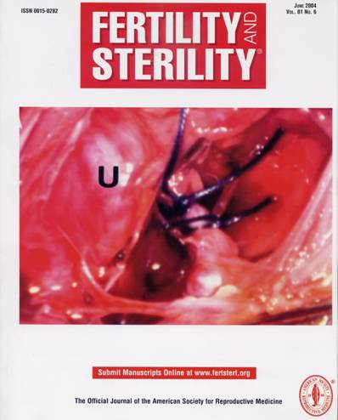
二、研究主題
- 加強腹腔鏡於臨床上的應用，雖然目前良性手術八成可以用腹腔鏡解決，但是婦科腫瘤仍是需要努力開拓的領域。
- 加強引進機器手臂，增加微創手術的領域。

三、研究成員
龔福財教授、黃富仁副教授、黃寬慧助理教授、藍國忠助理教授、林浩助理教授、曾智文醫師、歐育哲醫師、傅宏鈞醫師、莊斐琪醫師

四、人才培育與未來展望
目前院方預添購機器手臂，本科也積極派員學習與籌備。
五、主題研究相關成果
- Kung FT, Chen HC, Huang CC, Ho JT, Chen BH
Preservation of ovarian germinal follicles by temporary laparoscopic ovarian transposition in teenaged girls undergoing craniospinal irradiation for radiosensitive central nervous system tumors. Taiwan J Obstet Gynecol. 2008 Sep;47(3):300-4.
- Fu HC, Huang KH, Tseng CW, Liang HM, Lin H, Chou YJ, Kung FT.Comparison of clinical outcomes and spectral Doppler indices of uterine and ovarian stromal arteries in women undergoing myomectomy with or without hypogastric arterial ligation. Ultrasound Obstet Gynecol. 2006 Nov;28(6):831-6.
- Chou YJ, Ou YC, Lan KC, Jawan B, Chang SY, Kung FT. Preemptive analgesia installation during gynecologic laparoscopy: a randomized trial. J Minim Invasive Gynecol. 2005 Jul-Aug;12(4):330-5.
- Kung FT, Lin H, Hsu TY, Chang CY, Huang HW, Huang LY, Chou YJ, Huang KH. Differential diagnosis of suspected cervical pregnancy and conservative treatment with the combination of laparoscopy-assisted uterine artery ligation and hysteroscopic endocervical resection. Fertil Steril. 2004 Jun;81(6):1642-9.
- Lin H, Kung FT. Combination of laparoscopic bilateral uterine artery ligation and intraamniotic methotrexate injection for conservative management of cervical pregnancy. J Am Assoc Gynecol Laparosc. 2003 May;10(2):215-8.
- Shen CC, Wu MP, Lu CH, Kung FT, Huang EY, Chang HW, Yang LC, Hsu TY, Chang SY. Effects of closed suction drainage in reducing pain after laparoscopic-assisted vaginal hysterectomy. J Am Assoc Gynecol Laparosc. 2003 May;10(2):210-4.
- Shen CC, Mu MP, Kung FT, Huang FJ, Hsieh CH, Lan KC, Huang EY, Hsu TY, Chang SY. Major complications associated with laparoscopic-assisted vaginal hysterectomy: ten-year experience. J Am Assoc Gynecol Laparosc. 2003 May;10(2):147-53.
- Huang LY, Cheng YF, Huang CC, Chang SY, Kung FT. Incomplete vaginal expulsion of pyoadenomyoma with sepsis and focal bladder necrosis after uterine artery embolization for symptomatic adenomyosis: case report. Hum Reprod. 2003 Jan;18(1):167-71. Review
- Kung FT, Chen WJ, Chou HH, Ko SF, Chang SY. Conservative management of early endometrial adenocarcinoma with repeat curettage and hormone therapy under assistance of hysteroscopy and laparoscopy. Hum Reprod. 1997 Aug;12(8):1649-53.
- Kung FT, Hwang FR, Lin H, Tai MC, Hsieh CH, Chang SY. Comparison of laparoscopically assisted vaginal hysterectomy and abdominal hysterectomy in taiwan. J Formos Med Assoc. 1996 Oct;95(10):769-75.

- 高危險妊娠中心
- 本中心特色與目標
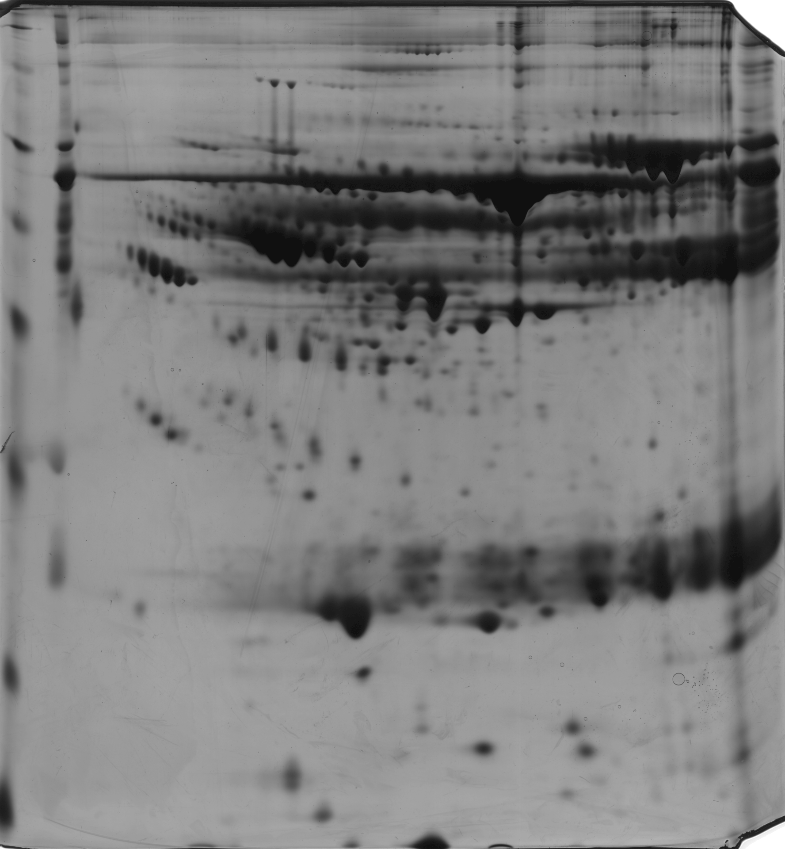
本科的中心特色是以高危險姙娠為主軸，包括早產、子癇前症、植入性胎盤相關的臨床及基礎研究，並包含流行病學的探討及嬰幼兒過敏防治的研究，目標為結合以前的成果進而作更深入的發展。目前更發展蛋白體學的研究，成果如下圖。
MW
(kDa)
pH
148
64
250
98
50
36
22
16
Linear
3
4
5
6
7
8
1
2
9
10
4
7
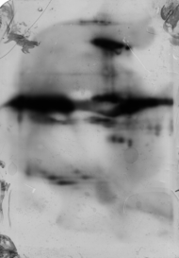
6
7
1
2
B
A

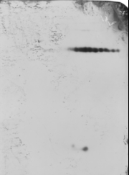
8
C

Figure (A) 2DE map of protein from plasma of severe preeclampsia women. The arrowheads are the signifficant differentially expressed spots between severe preecalmpsia women and normal pregnant women. (B) western blot of alpha 1 antitrypsin (C) western blot of alpha 1 microglobulin

二、研究成員
本科的研究人員有許德耀副部長、歐家佑主任、鄭碧華醫師及蔡慶璋醫師，並有3位研究助理協助
三、研究主題
1.基礎分子生物學研究:
2.產前診斷:
3.高危險姙娠病理生理學、偵測、風險評估的研究:
4.胎盤植入的解剖、基礎分子生物學研究:
5.產前、產中過敏流行病學及預防研究:

四、人才培育與未來展望
許副部長將會在子癇前症、早產及植入性胎盤等方面著手有關雄性素及蛋白質體的研究，歐家佑主任則延續產前益生菌對孕婦及嬰幼兒的研究更進一步深入的研究，目前鄭碧華醫師鄭於美國深造有關bioinformatics的領域，相信對她本人及科部內均有提升的功能，蔡慶璋醫師目前仍為協助的角色，也是本科積極培育的人才．

五、主題研究相關成果
已執行及申請中之研究計畫
1.國科會研究計畫:
第二次孕期正常懷孕與子癇前症台灣婦女血清中TNF-alpha.sTNFP55的濃度分析與子癇前症NMRPG9143
正常懷孕與子癇前症胎盤雄性素接受體及雄性素接受體輔助因子的基因表現NMRPG0154
以ferritin,interleukin-16 及interleukin-18合併陰道超音波來預測早產的發生率NMRPG2179
蛋白質分析在妊娠高血壓的應用NMRPG840241
台灣婦女發炎基因多型性, 血漿鉛, 和骨質密度之相關研究NMRPG2146細胞激素之基因型多形性對於骨質密度在更年期後婦女的關聯研究(1/2) NMRPG3209
細胞激素之基因型多形性對於骨質密度在更年期後婦女的關聯研究(2/2) NMRPG830112

2.長庚醫院院內研究計畫:
蛋白質分析在早產的運用蛋白質分析在早產的運用CMRPG850531
應用蛋白質體分析在唐氏症母體羊水與血漿蛋白質的比較CMRPG870171
孕婦食用益生菌預防嬰幼兒過敏病CMRPG84025
過敏孕婦使用益生菌症狀改善之免疫機轉探討CMRPG860291
受孕前後壓力性生活型態對醫師及其子代性別比之影響CMRP956
建立有鉛汽油消費期消失，空氣鉛與懷孕三期血與臍血鉛濃度與出生結果CMRP1224

3.申請中長庚醫院院內研究計畫:
胎盤內皮細胞醣類接受器之表現與子癲前症嚴重度之探討。
蛋白質體(proteomic)分析在植入性胎盤的研究
研究成果:發表論文
- 基礎分子生物學研究:

- Analysis of microsatellite instability in cervical cancer. Int J Gynecol Cancer 9: 67-71. 1999
- Urine free beta-hCG and total estriol for Down syndrome screening during the second trimester in an Asian population. Obstet Gynecol 94:107-11.1998
- Association of cord blood cytokines with prematurity and cerebral palsy. Early Hum Dev 77(1-2):29-36. 2004
- Shockwave stimulates oxygen radical-mediated osteogenesis of the mesenchymal cells from human umbilical cord blood. J Bone Miner Res 19(6):973-82. 2004

- 產前診斷:

- Assessment of the facial features and chin development of fetuses with use of serial three-dimentional sonography and the mandibular size monogram in a Chinese population. Am J Obstet Gynecol 190(2):541-6 2004
- Prenatal three-dimensional sonographic images associated with Treacher Collins syndrome. Ultrasoung Obstet Gynecol 19(4): 413-22. 2002 (SCI, A級)
- Prenatal sonographic appearance of Beare-Stevenson cutis gyrata syndrome: Two- and three-dimensional ultrasonographic findings. Prenat Diagn 8:665-7. 2001
- First trimester diagof holoprosencephaly and cyclopia with triploidy by transvaginal three-dimensional ultrasonography. Eur J Obstet gynecol Reprod Biol 96: 235-7. 2001
- Maternal serum screening for Down syndrome in pregnancies conceived by intra-uterine insemination. Prenat Diagn 19:1012-14. 1999
- Prenatal diagnosis of denovo interstitial deletion of proximal 4q by maternal serum screening for Down syndrome. Prenat Diagn 18:1323-7. 1998
- Prenatal diagnosis of a fetus harboring an intermediate load of the A3243G mtDNA mutation in a maternal carrier diagnosed with MELAS syndrome. Prenat Diagn 24(5):367-70. 2004
- Prenatal diagnosis of trisomy 20 mosaicism by maternal serum screening for Down syndrome. Eur J Obstet Gynecol Reprod Biol 86:175-7. 1999
- The experience of amnioinfusion for oligohydramnios during the early second trimester. Taiwan J Obstet Gynecol. 2007 Dec;46(4):395-8.

- 高危險姙娠病理生理學、偵測、風險評估的研究:

- Neonatal claviculai fructure: clinical analysis of incidence predisposing factors, diagnosis and outcome. Am J Perinatol 19(1): 17-21 2002
- The effects of Amnioinfusion on Uteroplacental and Fetal Circulation of second trimester pregnancy with oligohydramnios due to preterm premature rupture of membrance. (submit)
- Expression of androgen receptor in human placentas from normal and preeclampsic pregnancies(submit)
- Elevation of Interleukin-16 and Ferritin Concentrations in Early 2nd-Trimester Amniotic Fluid as a marker of preterm delivery. (submit)
- Use of proteome analysis as a biomarker screening tool in patients with preeclampsia (submit)

- 胎盤植入的解剖、基礎分子生物學研究:

- Failure of uterine arterial embolization: placenta accreta with profuse postpartum hemorrhage. Acta Obstet Gynecol Scand 83(7):688-90. 2004
- Conservative management of abnormally invasive placenta:Use of serial serum hCG levels and 3D placental volume as marks in the follow-up of placenta involution (submit)
- Prophylactic intraoperative uterine artery embolization to control hemorrhage in abnormal placentation during late gestation. Fertil Steril. 2008 May 22.

- 產前、產中過敏流行病學及預防研究:

- Infant frequent wheezing correlated to Clara cell protein 10 (CC10) polymorphism and concentration, but not allergy sensitization, in a perinatal cohort study. J Allergy Clin Immunol. 2007 Aug 21
- Interaction of maternal atopy, CTLA-4 gene polymorphism and gender on antenatal immunoglobulin E production. Clin Exp Allergy. 2007 May; 37(5):680-7.
- Correlation of augmented IL-8 production to premature chronic lung disease: implication of posttranscriptional regulation. Pediatr Res. 2005 Aug; 58(2):216-21.
- Gender-limited association of cytotoxic T-lymphcyte antigen-4 (CTLA-4) polymorphism with cord blood IgE levels. Pediatr Allergy Immunol 15(6):506-12. 2004
- Association of cord blood cytokines with prematurity and cerebral palsy. Early Hum Dev 77(1-2):29-36. 2004
- Implication of cord blood myeloperoxidase but not of soluble p-selectin levels in preterm deliveries. J Perinat Med 32(1):49-52. 2004
- Polymorphism of the immune-braking gene CTLA-4 (+49) involved in gender discrepancy of serum total IgE levels and allergic diseases. Clin Exp Allergy 34(1):32-7. 2004
- Prenatal prediction of infant atopy by maternal total IgE levels. J Allergy Clin Immunol 112(5):899-904. 2003
- A model to study antioxidant regulation of endotoxemia-modulated neonatal granulopoiesis and granulocyte apoptosis. Pediatr Res 6:829-34. 2000

4.婦女尿失禁治療中心
- 本科中心特色與目標
關於婦女下泌尿道症狀及骨盆鬆弛，包括尿失禁、排尿障礙、膀胱過動及骨盆臟器脫垂，我們提供完整的理學檢查、婦產科超音波、尿動力學檢查、膀胱鏡檢查，力求詳盡的評估及精確的診斷和最佳治療。
在保守治療方面，有專業的尿失禁防治指導員提供物理治療，包括膀胱訓練，凱格爾運動 (Kegel’s exercise) ，生理迴饋 (Biofeedback) ，電刺激療法 (Electronic stimulation) ，教導子宮拖使用與體外磁波治療。
手術特色，除了傳統手術方式，更具備最新手術方式之能力，結合微創與人工網膜 (TVT-O, MONARC, Perigee, Apogee, Prolift)，追求最佳的手術預後與成功率。同時更致力在疾病診斷學的研究如下圖。

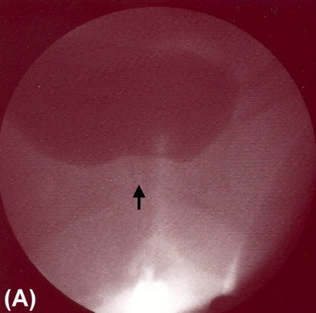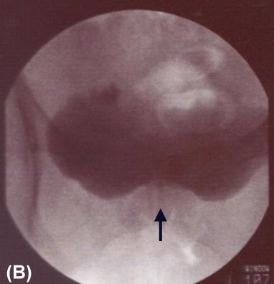
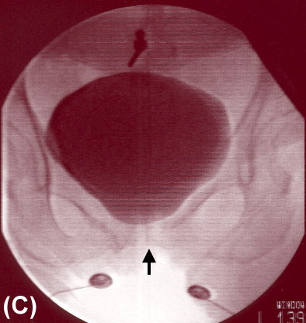
Filling cystourethrography in
patients (A) with mild and (B)
with moderate or (C) without
bladder base elevation.
Neurourol Urodyn 2007;26(4):502-6.
- 研究主題
  - 尿失禁手術合併骨盆重建手術短期及長期預後追蹤
  - 尿失禁手術合併腹腔鏡全子宮切除手術之結果
  - 嚴重骨盆脫垂手術前後之臨床及尿動力學表現
  - 嚴重骨盆脫垂合併隱藏性尿失禁之手術方式
  - 基質細胞對婦女骨盆底鬆弛及人工網膜癒合調控之角色研究

- 研究成員
龔福財教授、黃寬慧助理教授、莊斐琪醫師、許惠貞技術員

- 人才培育與未來展望
基於對骨盆鬆弛及排尿障礙複雜的解剖及病生理學能有更深入的探討及研究，希望能增設錄影尿動力學檢查設備，將傳統的尿動力學檢查結合影像學達到最完整的下泌尿道評估，以求具備處理複雜病例的能力。

- 主題研究相關成果
- Huang KH, Kung FT, Liang HM, Huang LY, Chang SY Concomitant surgery with tension-free vaginal tape Acta Obstet Gynecol Scand. 2003 Oct;82(10):948-53.
- Huang KH, Kung FT, Liang HM, Chang SY. Management of polypropylene mesh erosion after intravaginal midurethral sling operation for female stress urinary incontinence. Int Urogynecol J Pelvic Floor Dysfunct. 2005 Nov-Dec;16(6):437-40.
- Chen CW, Huang KH, Liang HM, Hsu HT, Kung FT. A comparison of urodynamic parameters and lower urinary tract symptoms in urodynamic genuine stress incontinence women with or without stress urinary incontinence. Chang Gung Med J. 2004 Aug; 27(8):594-601.
- Huang KH, Kung FT, Liang HM, Chen CW, Chang SY, Hwang LL. Concomitant pelvic organ prolapse surgery with TVT procedure. Int Urogynecol J Pelvic Floor Dysfunct. 2006 Jan;17(1):60-5.
- Liang HM, Huang KH, Kung FT, Chen CW, Chang SY. Combination of a tension-free vaginal tape procedure and laparoscopic-assisted vaginal hysterectomy for the treatment of benign uterine disease associated with stress urinary incontinence. Chang Gung Med J. 2005 Mar; 28(3):166-73.
- Chung FC, Kuo HC. Is bladder base elevation a sign for pelvic floor hypertonicity in women with lower urinary tract symptoms ? ICS 2006 Abstract CD-ROM, abstract number 409
- Chung FC, Kuo HC. Correlation of bladder base elevation with pelvic floor hypertonicity in women with lower urinary tract symptoms. Neurourol Urodyn 2007;26(4):502-6.
- Chung FC, Kuo HC. The urological complications of radical hysterectomy for uterine cervical cancer. (Mini review) Incontinence & Pelvic Floor Dysfunction 2007; 1(3): 77-80.
- Yee YH, Lu CC, Kung FT, Huang KH. Rectocutaneous fistula: a rare complication of the posterior intravaginal sling. Int Urogynecol J Pelvic Floor Dysfunct. 2008 Apr;19(4):599-601.
- Chung FC, Kuo HC. Management of lower urinary tract dysfunction after radical hysterectomy with or without radiotherapy for uterine cervical cancer. Journal of the Formosan Medical Association (manuscript ID: A3999) submitted.
- Chung FC, Kuo HC. Videourodynamic evaluation of urge syndrome following pubovaginal sling procedure for stress urinary incontinence in women. Neurourol Urodyn. (manuscript ID: NAU-08-0155,R1) submitted.
- Chung FC, Kuo HC. Prevalence of Lower Urinary Tract Symptoms in Female Aborigines and Non-aborigines in Eastern Taiwan. International Urogynecology Journal (manuscript ID：IUJ 11-08-0527) submitted.

5.婦癌研究中心
婦癌科自創立成長以來，一直將完美的臨床服務和尖端的基礎研究，列為最重要的發展目標，獲得無數的口碑與好評，可說是南臺灣婦癌的重鎮。同時編屬在本院癌症中心。詳見癌症中心介紹單元。

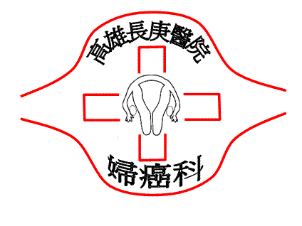

圖片說明:由本科自行研發的人類乳突病毒基因型偵測法，不但簡單而且準確。目前已大量運用於臨床檢測及醫學研究。

6.性荷爾蒙醫學研究中心
Center for Sex Hormone Medicine Research, Chang Gung Memorial Hospital, Kaohsiung, Taiwan
性荷爾蒙醫學研究中心
特色
本中心招募、邀請長庚大學及長庚紀念醫院對荷爾蒙研究有志同仁及國際合作團隊，共同推展荷爾蒙醫學相關研究。

目標
Phase I
- 闡明性荷爾蒙，特別是雄性激素對骨骼成長與代謝的關係，和骨鬆基因體及幹細胞之研究。
- 提攜後進培育新秀延續研究工作。
Phase II
- 研究性荷爾蒙對相關疾病的作用機轉。
- 研究治療荷爾蒙相關疾病的新藥。
- 貢獻荷爾蒙相關疾病的臨床診療。

研究主題
研究群組架構(以各主持人專長為導向)

性荷爾蒙醫學研究中心
總主持人:黃國恩教授

研究群組方向

荷爾蒙與骨骼研究群之整合架構(以骨骼成長與代謝為基準)
研究計畫
性荷爾蒙醫學研究中心整合型總計畫

研究成員
核心研究團隊
- 高雄長庚婦產部-黃國恩教授、鄭碧華醫師、蔡孟穎醫師、藍國忠醫師
- 長庚大學臨研所-康宏佑副教授
- 慈濟大學醫技系-石志榮助理教授
- 國際合作研究團隊(美國羅徹斯特大學喬治韋伯實驗室)
研究助理
- 碩士級專任研究助理-翁珮鈴、林欣蓉、張雲喬、吳慧貞、郭珊足、洪翊恬、林姵君、丁肇瑩、王舒右
- 學士級專任研究助理-黃肇駿、陳俞蓁
- 兼任博士生-謝昶毅
- 兼任碩士生-蕭伯倫
- 工讀生-王大玉、朱時正、吳聲鑫、黃鈺婷

人才培育
- 指導臨床醫師研究計劃
- 臨研所博士班學生-婦產部鄭碧華醫師、中醫系吳清源醫師
- 臨研所碩士班學生-血液腫瘤科饒坤銘醫師、新陳代謝科周振凱醫師、婦產部傅宏鈞醫師
- 定期舉辦臨床研究討論會並提供諮詢(每週四下午16:00-18:00)
- 將表現優異的研究助理(馬如龍、林城兆、黃瓊葵)送至美國羅徹斯特大學喬治韋伯實驗室攻讀博士班繼續進修

未來展望
1. 建立基因剔除小鼠對骨鬆及荷爾蒙相關疾病之動物模式。
2. 探討解明雄性激素對骨骼成長與代謝之機轉。
3. 了解雄性激素受體與互動分子間的訊息傳遞。
4. 建立台灣人荷爾蒙接受器之基因圖譜。
5. 將研究結果付諸臨床應用。

主題研究相關成果
- 近五年內核心團隊成員SCI期刊論文發表成果
Impact factor 5-10, 25%

Impact factor
2以下, 25%

Impact factor 2-5, 50%

*限第一作者及通訊作者
- Selected publication(近五年內代表性著作)
發表年份 | 代表性著作
2003 | (1)Pan, H. A., Wang, S. T., Pai, M. C., Chen, C. H., Wu, M. H., and Huang, K. E. Cognitive function variations in postmenopausal women treated with continuous, combined HRT or Tibolone. J. Repro. Med. 48:375-380, 2003.  (2)Tsai, M. Y., Lan, K. C., Huang, K. E., Huang, F. J., Kung, F. T., Chang, S. Y. Significance of mRNA levels of connexin37, connexin43, and connexin45 in luteinized granulosa cells of controlled hyperstimulated follicles. Fertil Steril 80: 1437-43, 2003.  (3)Lan, K. C., Huang, F. J., Lin, Y. C., Kung, F. T., Hsieh, C. H., Huang, H. W., Tan, P. H., Chang, S. Y. The predictive value of using a combined Z-score and day 3 embryo morphology score in the assessment of embryo survival on day 5. Hum Reprod 18: 1299-1306, 2003.
2004 | (1)Tsao, L. I., Huang, K. E. : Effectiveness of a perimenopausal health education intervention for mid-life women in northern Taiwan. Patient Education and Counseling 54:321-328, 2004.  (2)Kang, H. Y., Cho, C. L., Huang, K. L., Wang, J. C., Hu, Y. C., Lin, H. K., Chang, C., and Huang, K. E.: Nongenomic androgen activation of phosphatidylinositol 3-kinase/Akt signaling pathway in MC3T3-E1 osteoblasts. JBMR 19:1181-1190, 2004.  (3)Tsai, M. Y., Lan, K. C., Ou, C. Y., Chen, J. H., Chang, S. Y., Hsu, T. Y. Assessment of the dynamic change of facial features and chin development of fetuses between 15 and 35 weeks of gestation using serial three-dimensional sonography and the mandible growth chart. Am J Obstet Gynecol, 190: 541-6, 2004.  (4)Chen, C.W., Hsu, T. Y., Chang, S. Y., Tsai, M. Y. Total parenteral nutrition treatment in a diabetic pregnant women complicated with hyperemesis gravidarum, malnutrition and intrauterine growth retardation. Taiwanese J Obstet Gynecol 43: 67, 2004.  (5)Huang, F. J., Lan, K. C., Kung, F. T., Tsai, M. Y., Chang, C. Y., Huang, H. W., Lin, Y. C., Chang, S. Y.. Human cumulus-free oocyte maturational profile and in vitro developmental potential after stimulation with recombinant versus urinary FSH. Hum Reprod 19: 306-315, 2004.
2005 | (1)Huang, F. J., Hsu, Y. C., Kang, H. Y., Chang, S. Y., Hsuuw, Y. D., and Huang, K. E. Effects of retinoic acid on the inner cell mass in mouse blastocysts. Fertil. Steril. 83:238-242, 2005.  (2)Chang, S.Y., Kang, H. Y., Lan, K. C., Chang, C. Y., Huang, F. J., Tsai, M. Y., Huang, K. E.. Expression of steroid receptors, their cofactors, and aromatase in human luteinized granulosa cells after controlled ovarian hyperstimulation. Fertility and Sterility. 2005. Apr; 83 Suppl 1:1241-1247.  (3)Rau,* K. M., Kang, H. Y.*, Cha, T. L., Miller, S. A., Hung, M. C.. The mechanisms and managements of hormone-therapy resistance in breast and prostate cancers. Endocrine related cancer. 2005, Sep 1; 12(3):511-532. (*equal contribution)
2006 | (1)Huang, F. J.,Hsu, Y. C., Kang, H. Y., Hsuuw, Y. D., Chang, S.Y., Huang, K. E. The adverse effects of retinoic acid and expression of retinoic acid receptors on mouse blastocyst development. Human reproduction. 2006, Jan; 21(1):202-9.  (2)Chang, J. Y., Hsuuw, Y. D., Huang, F. J., Huang, C. K., Shyr, C. R., Chang, S. Y., Kang, H. Y., Huang, K. E. Androgen signaling and the expression of androgen receptor in mouse blastocysts and embryonic stem cells. Fertility and Sterility, 2006, Apr: 85(1):1195-1203.  (3)Chang, S. Y., Kang, H. Y., Lan, K. C., Hseh, C. Y., Huang, F. J., Huang, K. E. Expression of inhibinactivin subunits, follistatin and smads in granulosa-luteal cells collected at oocyte retrieval. J Assist Reprod Genet. 2006 Oct;23(9-10):385-92.  (4)Tsai, M. Y., Yeh, S. D., Wang, R. S., Yeh, S., Zhang, C., Lin, H. Y., Tzeng, C. R., Chang, C. Differential effects of spermatogenesis and fertility in mice lacking androgen receptor in individual testis cells. Proc Natl Acad Sci U S A. 12;103(50):18975-80. Epub 2006 Dec 1.  (5)Tsai, M. Y., Yeh, S. D., Wang, R. S., Yeh, S., Zhang, C., Lin, H. Y., Tzeng, C. R., and Chang, C. Differential effects of spermatogenesis and fertility in mice lacking androgen receptor in individual testis cells. Proc Natl Acad Sci U S A. 2006 Dec; 103(50):18975-18980.
2007 | (1)Yu, S. F., Cheng, T. T., Hsu, Y. H., Lai, H. M., Chen, Y. C., Chiu, C. K., Lin, K. M., Chang, C., Chen, C. J. and Kang, H. Y. Association trinucleotide (CAG and GGC) repeat polymorphism of androgen receptor gene in Taiwanese women with refractory or remission rheumatoid arthritis. Clinical Rheumatology. 2007, 26:2051-2058.
2008 | (1)Lan, K. C., Hseh, C. Y., Lu, S. Y., Huang, F. J., Shyr, C. R., Chang, S . Y., Huang, K. E., Kang, H. Y. Expression of the Androgen Receptor Coregulators as a Function of Testis Disorders in Infertile Men with Azoospermia. Fertility and Sterility. 2008, Vol 89, Suppl 3, May, 1397-1405.  (2)Kang, H. Y., Huang, C. K., Shyr, C. R., Tsai, M. Y., Chang, C., Huang, K. E. Altered TNSALP  Expression and Phosphate Regulation Contribute to Reduced Mineralization in Mice Lacking  Androgen Receptor. Molecular Cellular Biology. 2008. (Paper acepted).  (3)Kang, H. Y., Huang, H. Y., Hseh, C. Y., Li, C. F. , Shyr, C. R., Tsai, M. Y., Chuang, Y. C., Chang, C.,  Ma, W. L. and Huang, K. E. Activin A Contributes to the Bone Metastasis of Prostate Cancer by  Promoting Cancer Cell Migration through Androgen Receptor. JBMR. 2008. (Paper acepted)

跨科合作
性荷爾蒙醫學研究中心
跨院校及國際合作
性荷爾蒙醫學
研究中心

